**Named Switch**



We renamed the switch “Team 2 (Switch P)” after we adopted it.

**VLAN Setup**

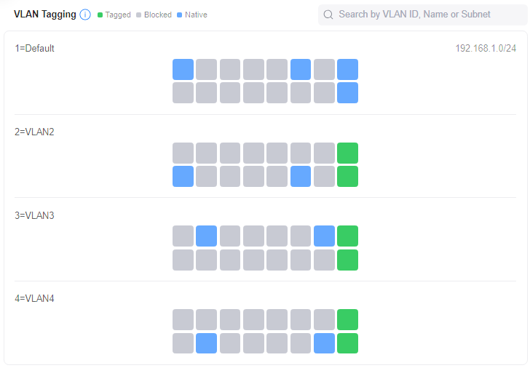

VLAN 1 is set to access on ports 1 & 11.

VLAN 2 is set to access on ports 2 & 12.

VLAN 3 is set to access on ports 3 & 13.

VLAN 4 is set to access on ports 4 & 14.

Ports 15 & 16 are set to trunk on VLAN’s 2, 3, and 4, and native on 4.

**VLAN 2 Server**

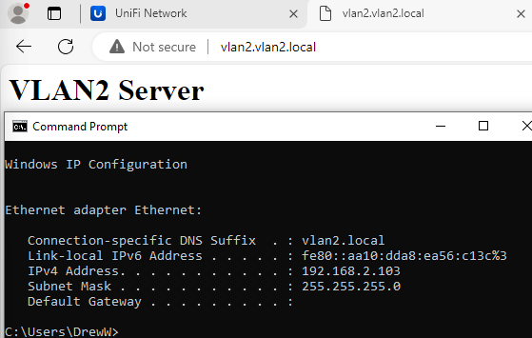

This shows that while on VLAN 2 (port 12), we were able to access the webserver on VLAN 2. Notice the 192.168.**2**.103 address.

**VLAN 3 Server**

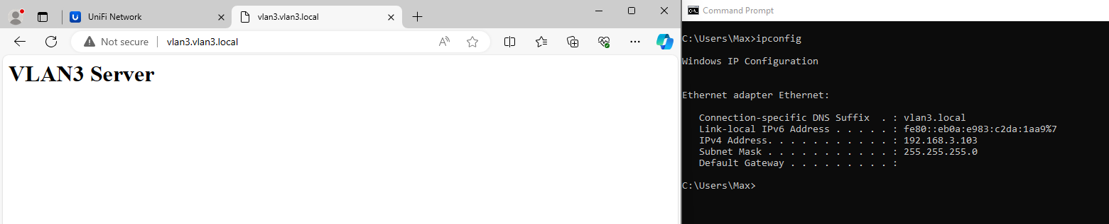

This shows that while on VLAN 3 (port 3), we were able to access the webserver on VLAN 3. Notice the 192.168.**3**.103 address.

**VLAN 4 Server**

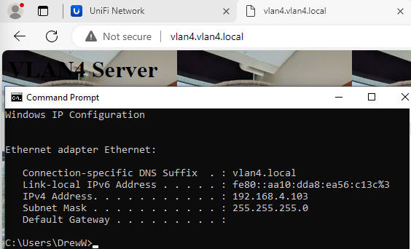

This shows that while on VLAN 4 (port 14), we were able to access the webserver on VLAN 4. Notice the 192.168.**4**.103 address.